交通指南 Direction
圣地亚哥国际机场San Diego International Airport (SAN)
机场电话Airport TEL. +1 619-400-2404
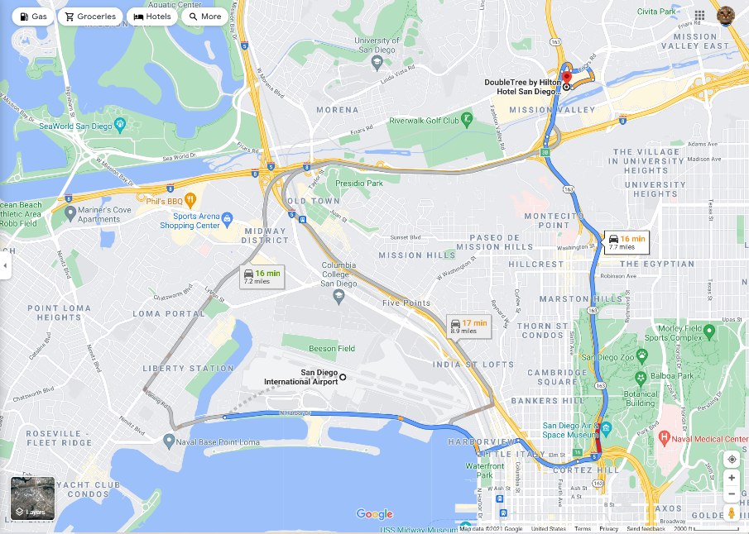
接机Airport Pick Up:
机场至酒店没有班车。会务组将安排接机。Hotel shuttle service is not available. The conference committee will arrange pick up and send off. 接机时间schedules are：
San Diego 机场（12/10 周五11AM-11PM）。
Los Angeles 机场（12/10中午12PM，及晚上8PM，各一班。稍等成组，而后成行）。
其他机场：自理。

会务组电话：858-382-9542 抵达后请电话联系接机 Please call for pick up upon arrival.

自驾Drivers：
From San Diego international airport:
Get on I-5 S. Take CA-163 N to Friars Road. Take exit 3B from CA-163 N. Follow Friars Road, Frazee Road, Hazard Center Drive to the hotel. (Or, Take Rosecrans Street, I-8 East, and Exit 4C to Frazee Road.)
From Los Angeles international airport:
Get on I-105 E. Take I-405 S, I-5 S, I-805 S. Take Exit 20 to merge onto CA-163 S towards Downtown. Take Exit 4 for Friars Road. Continue onto Friars Road to the hotel.

酒店泊车 Hotel Self-Parking
酒店停车场大会协议价$10/晚 Hotel Self-Parking $10/night for conference attendees.
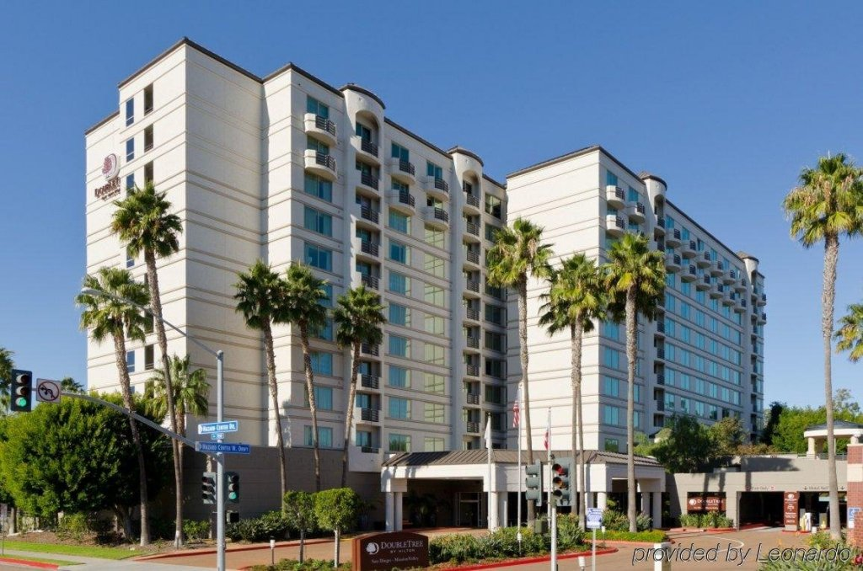
双树-希尔顿大酒店Double Tree by Hilton Hotel San Diego-Mission Valley
7450 Hazard Center Drive, San Diego, CA 92108, United States
TEL. + 1 619-297-5466
大会报到 Registration for the Conference:
12月10日星期五中午12:00 开始 Starting Friday, December 10th, 12:00 NOON)

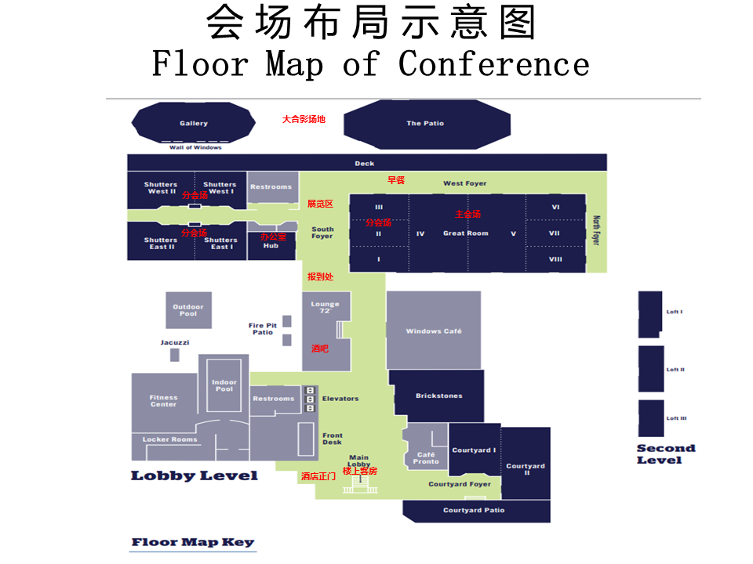

注意事项( Things to Know)
1. 停车（Parking）：酒店停车场会议协议价$10/晚。Hotel self-parking $10/night for conference attendees.
2. 机场班车接送（San Diego Airport pick up）：机场至酒店没有班车。大会会务组将根据抵达和起飞时间按排接送。 (No shuttle service between San Diego airport and the Double Tree Hotel. Pick up will be arranged by the conference committee. Call 858-382-9542 for pick up upon arrival.
3. 天气（Weather）：圣地亚哥12 月平均气温为华氏66° / 51°度。 (Average temperature in San Diego in December is between 66° / 51°F.)
4. 酒店入住于当日下午3点后，请注意酒店事项与有关的一切费用，概由个人与酒店交涉，大会组织者不承担任何责任。若比预订天数提前离开，请尽早通知酒店。酒店对提前离开者有收费的规定。客房内的消费品，有可能要另外收费，请看清楚后再消费。退房手续需在当日中午12 点以前办好，12/12当天可延缓至下午一点，过时可能会产生额外费用。 (Daily check-in after 3pm, check-out before 12pm. Sunday 12/12 check-out extends to 1pm. All hotel related expenses are sole responsibility of each individual. If you stay less nights than you reserved, an early departure fee may be charged.)
5. 酒店禁止吸烟。入住酒店期间，酒店清洁人员打扫房间后，请酌情付给小费。 (Smoking is NOT allowed in the hotel. Please leave tips for room cleaning as needed.)
6. 按照协会与酒店的优惠协议, 客房提供免费无线上网服务。办理入住手续时领取密码。在整个酒店的任何地方（除会议厅外）使用自备电脑连接上网。不保证上网效果，取决于笔记本的接收能力。 (Free WiFi in guestroom per value added concession use. No guarantee outside guestroom.)
7. 按照协会与酒店的优惠协议，免费使用健身房和游泳池。 (The fitness center and 2 swimming pools are free for use.)
8. 代表证是参加会议和活动及就餐的有效凭证，请妥善保管，会议期间请随身佩戴。如有遗失，请及时向会议登记台报告。 (The name tag is your ID to the conference and activities, as well as meals. Please wear it throughout the conference.)
9. 星期五晚上、星期六和星期天早上中午的餐饮由大会提供。到会代表凭票领取。周六晚宴按姓名入座。由于酒店规定我们不得在公用场合提供食品给大家，请大家在指定的地点用餐。 (Meals on Friday (dinner), Saturday and Sunday (breakfast and lunch) are provided by the Conference on-site. Saturday banquet is seated by names. Meal vouchers must be presented when entering the dining area. Due to the regulations of the hotel, please stay in the designated areas for all dinning.)
10. 大会和分组讨论发言者，请提前与主持人联系，提交电子文件资料。主持人需要提前取得电脑和投影仪并测试。 (Presenters, please contact the Chair of your session to submit electronic presentation files. The Chairs will provide computer and projector and test them prior to each session.)
11. 进入会场后请关闭手机或静音。 (Please turn off or silent cellular phone in the conference room.)
12. 星期六晚上颁奖典礼, 请领奖人注意你所在的颁奖小组, 按颁奖的顺序上台领奖。 (Award Ceremony in Saturday evening is proceeded by the categories listed in order. Award winners please pay attention to the category for which you are awarded and approach to the stage orderly.)
13. 请保管好圣地亚哥旅游车票，星期一凭票上车。 (Be sure to keep your tour ticket and have it ready for San Diego tour on Monday. )
14. 星期六大会开幕式，全体合影，及晚上的颁奖活动，请与会代表着职业正装。 (Business attire for Saturday Opening Ceremony, group photo and dinner banquet.)

